SIMATS ENGINEERING
ASSESSMENT TOOL 1 - Concept Mapping

COURSE NAME: Data Structures COURSE CODE: CSA03
Register Number | 192424245
Name | g.vinay kumar reddy

COURSE OUTCOME COVERED

CO1: Apply suitable data structures and ADTs for efficient problem solving by analyzing time and space complexity. (BL2, BL3)

Assessment Tool Weightage: 35%

Questions:2 | EACH QUESTIONS CARRIES: 10 MARKS Total Marks:20 Duration: ONE HOUR
Q1 A smart healthcare system processes large volumes of patient data such as temperature readings, medical history, and diagnostic details. Construct a concept map linking the progression from Data → Data Object → Data Structure → Abstract Data Type (ADT) → Implementation in C. Identify relevant sub-concepts such as structures, pointers, and operations, and establish meaningful relationships among them. Organize the concept map hierarchically and justify how each level contributes to efficient data organization, processing, and improved system performance.
Q2 A smart city traffic management system handles data related to vehicle movement, road networks, and signal control. Construct a concept map connecting Primitive Data Structures → Non-Primitive Data Structures → Linear → Non-Linear Structures. Include examples such as arrays, linked lists, trees, and graphs, and illustrate their applications in traffic management. Explain the relationships between these structures and justify their classification based on functionality and efficiency.

Code of Conduct:

I _g.vinay kumar reddy (192424245) (Name / Reg No) certify that this submission is my original work and that I have adhered to the guidelines specified for this assessment.
I understand that any violation of academic integrity rules will result in disciplinary action.

vinayyy
Signature of the student:

RUBRICS FOR CALCULATION:

Concept Mapping
Criteria | Weightage | Level 4 (Exemplary) | Level 3 (Proficient) | Level 2 (Developing) | Level 1 (Beginning)
Concept Identification | 25% | Identifies all key concepts from literature accurately and comprehensively | Identifies most key concepts with minor omissions | Identifies limited concepts; some are irrelevant or missing | Fails to identify essential concepts
Linkages | 25% | Establishes clear, meaningful, and accurate relationships between concepts | Shows correct relationships with minor gaps | Relationships are weak, unclear, or partially incorrect | No meaningful relationships established
Organization | 20% | Concepts are well-structured hierarchically with logical flow and grouping | Mostly organized with minor structural issues | Some organization but lacks clear hierarchy | No logical organization or structure
Integration of Literature | 20% | Integrates multiple studies effectively to show connections and comparisons | Shows some integration of literature | Limited integration; mostly isolated concepts | No integration of literature evidence
Clarity | 10% | Concept map is clear, neat, visually structured, and easy to interpret | Generally clear with minor readability issues | Clarity is reduced; difficult to interpret in parts | Poorly presented and hard to understand

Q1 A smart healthcare system processes large volumes of patient data such as temperature readings, medical history, and diagnostic details. Construct a concept map linking the progression from Data → Data Object → Data Structure → Abstract Data Type (ADT) → Implementation in C. Identify relevant sub-concepts such as structures, pointers, and operations, and establish meaningful relationships among them. Organize the concept map hierarchically and justify how each level contributes to efficient data organization, processing, and improved system performance.

Ans)A smart healthcare system deals with a large amount of patient information such as temperature, blood pressure, patient name, age, medical history, diagnosis and laboratory reports. To manage this information properly, it can be understood through the progression Data → Data Object → Data Structure → Abstract Data Type (ADT) → Implementation in C.
Data
Data is the basic raw information collected by the healthcare system. For example, a patient's temperature may be 98.6°F, the patient's name may be Ravi, and the diagnosis may be Diabetes. These individual values are initially just pieces of information.
The relationship can be represented as:
Data → grouped into → Data Objects
Data Object
A data object is a meaningful entity created by grouping related data. For example, all the information related to one patient can be treated as a single patient object. It may contain the patient ID, name, age, temperature and medical history.
For example:
Patient
├── Patient ID
├── Name
├── Age
├── Temperature
└── Medical History
This makes the information easier to identify and manage.
Data Structure
When the system has thousands of patient objects, simply storing them individually is not efficient. A data structure provides a systematic way of organizing these objects.
Different structures can be selected depending on the requirement. An array can store temperature readings, while a linked list can store patient history or dynamically changing patient records. Trees and other structures can be used when faster searching or hierarchical organization is required.
For example, daily temperature readings can be stored using an array:
float temperature[5] = {98.6, 99.1, 100.2, 101.4, 98.9};
Here, the array keeps multiple temperature values together and allows them to be accessed using an index.
The relationship is:
Data Objects → organized using → Data Structures
Abstract Data Type (ADT)
An Abstract Data Type describes what can be done with a collection of data without explaining how the operations are implemented internally.
For example, a patient-record ADT may provide operations such as:
Insert()
Delete()
Search()
Update()
Display()
The important point is that an ADT focuses on what operations are required, while the actual implementation is hidden from the user.

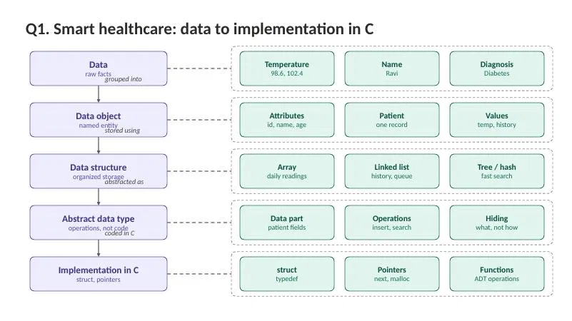
For example:
Patient ADT → Insert patient → Search patient → Update patient → Delete patient
This abstraction makes the program easier to understand and maintain.
Implementation in C
The ADT and data structures can be implemented using C features such as structures, pointers and functions.
A structure can be used to combine different types of patient information into a single record.

#include <stdio.h>
struct Patient {
int id;
char name[50];
float temperature;
};

int main() {
struct Patient p = {101, "Ravi", 98.6};

printf("Patient ID: %d\n", p.id);
printf("Name: %s\n", p.name);
printf("Temperature: %.1f\n", p.temperature);

return 0;
}
Q2 A smart city traffic management system handles data related to vehicle movement, road networks, and signal control. Construct a concept map connecting Primitive Data Structures → Non-Primitive Data Structures → Linear → Non-Linear Structures. Include examples such as arrays, linked lists, trees, and graphs, and illustrate their applications in traffic management. Explain the relationships between these structures and justify their classification based on functionality and efficiency

Ans)
A smart city traffic management system handles information such as vehicle count, speed, traffic signals, roads and routes. Data structures help organize this information and process it efficiently.

The main classification is:
Data Structures → Primitive and Non-Primitive → Linear and Non-Linear

Primitive Data Structures
Primitive data structures are basic data types such as int, float and char. In traffic management, int can store vehicle count, float can store speed and char can represent signal status.

int vehicleCount = 125;
float speed = 48.5;
char signal = 'R';

Non-Primitive Data Structures
Non-primitive structures store collections of data and are divided into Linear and Non-Linear structures.
Linear Data Structures
Linear structures arrange data in a sequence. Examples are Array, Linked List, Stack and Queue.
Array: Used for storing hourly vehicle counts or signal timings.
int vehicles[5] = {120, 150, 180, 210, 175};
Linked List: Stores dynamically changing information such as vehicles waiting or traffic incidents.

struct Node {
int vehicleID;
struct Node *next;
};

Stack: Follows LIFO (Last In, First Out) and can be used for route backtracking and DFS.
stack[++top] = 101; // Push
int x = stack[top--]; // Pop
Queue: Follows FIFO (First In, First Out) and is suitable for vehicles waiting at a red signal.
queue[++rear] = 101; // Enqueue
int x = queue[front++]; // Dequeue
Non-Linear Data Structures
Non-linear structures represent hierarchical or interconnected relationships. The main examples are Tree and Graph.
Tree: Represents hierarchy such as:
City → Zone → Area → Junction → Road
Graph: Represents the road network. Intersections are represented as nodes, roads as edges, and distance or congestion can be represented as weights.
int graph[4][4] = {
{0, 1, 1, 0},
{1, 0, 1, 1},
{1, 1, 0, 1},
{0, 1, 1, 0}
};

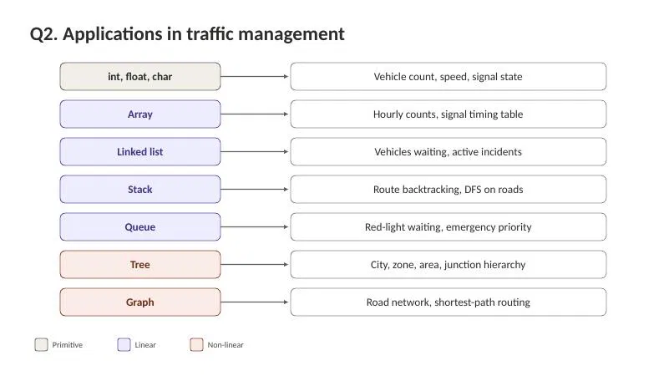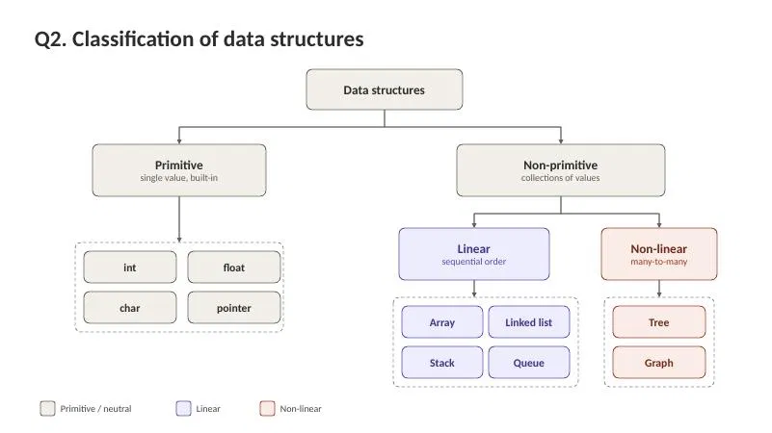A graph can be used for shortest-path and route selection.
Relationships
Array / Linked List → Stack / Queue
Stack → DFS → Graph
Queue → BFS → Graph
Tree → Hierarchical structure
Thus, arrays are useful for fixed data, linked lists for changing data, stacks for backtracking, queues for waiting vehicles, trees for hierarchy and graphs for road networks. Selecting the right data structure improves processing speed, memory usage, route planning and overall traffic management efficiency.

